11/09/25

# Power Bi Dashboard

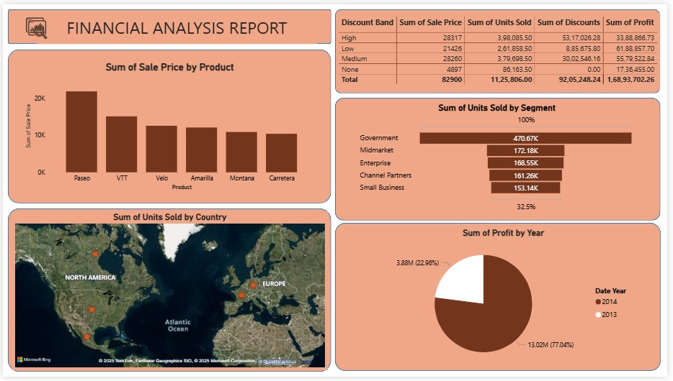

Add a shape for good looking and add text box name at financial analysis report and add icon for heading.

1.To create a **stacked Column chart:**

1. go to **Visualizations** and select the stacked column chart.
2. On the **X-axis**, place the **Product** field.
3. On the **Y-axis**, place the **Sales** field.
   * It will automatically change to **Sum of Sales**.
4. Change color for column and chart effects.
5. Add a shape for background.

2.To create a **Map:**

1. go to **Visualizations** and select the map.
2. On the **Location**, place the **Country** field.
3. On the **Latitude**, place the **Unit sold** field.
   * It will automatically change to **Sum of Unit sold**.
4. Change style and effects.
5. Add a shape for background.
6. Visual → Bubbles → Size → Color

3. To create a **Table:**

1. go to **Visualizations** and select the Table.
2. On the **columns**, place the **Discount band, Sales price, Unit sold, Discount,** **Product** field.
   * It will automatically change to **Sum of Discount band, Sum of Sales price, Sum of Unit sold, Sum of discount, Sum of profit**.
3. Change Grid line color , column color, font color and chart effects.
4. Add a shape for background.

4. To create a **Funnel:**

1. go to **Visualizations** and select the Funnel.
2. On the **Category**, place the **Segment** field.
3. On the **Values**, place the **Unit sold** field.
   * It will automatically change to **Sum of Unit sold**.
4. Data labels on → Position → inside center.
5. Category label on.
6. Conversion rate label on.
7. Change color and effects.
8. Add a shape for background.

5. To create a **Pie Chart:**

1. go to **Visualizations** and select the Pie chart.
2. On the **Legend**, place the **Date** field.
3. On the **Values**, place the **Profit** field.
   * It will automatically change to **Sum of Profit**.
4. Change color and chart effects.
5. Add a shape for background.

**Create a new report named it Team project**

Add a data set of performance details